From: http://davidstockmanscontracorner.com/the-lemmings-final-run/

The Lemmings' Final Run
By David Stockman. Posted On Friday, August 24th, 2018
We are not sure which images is more salient---the chart of yesterday's run of the Russell 2000 to an all-time high of 1724 or the standard image of lemmings spilling into the Irish Sea from the cliffs high above.
We present both graphical images below owing to the fact that yesterday the proverbial cliff came into sharp focus on the Washington end of the Acela Corridor. To wit, the door suddenly swung open to a whole new ball game on the Mueller probe and an upcoming partisan civil war over 2016 election meddling of epic proportions.
But the lemmings of Wall Street did not take the slightest notice----meaning that their encounter with the freezing, swirling bath below is only a matter of months or even weeks away. That is, the chart-point monkeys and the bulled-up boys and girls in the casino have reached the point where they are absolutely deaf, dumb and blind to anything happening on the planet outside their own gaming tables.
Indeed, the outside world has been reduced to the risible meme that the US economy is "strong". So buy the dips!
As we document day after day, of course, that flies in the face of the facts; and it is also an utterly specious point to make this late in the business cycle under circumstances in which unprecedented monetary tightening is colliding head-on with a monumental eruption of the Federal deficit and US Treasury demand for funds.
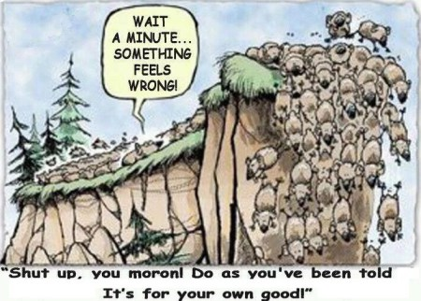
In this context, the Washington death cliff we are speaking about was signaled yesterday by Senators Lindsey Graham and Chuck Grassley, the two top GOP dogs on the Senate judiciary committee. Their crystal clear message to the Donald was that on the day after the mid-term elections, if not before, he should feel free to shit-can his pathetically feckless Attorney General, Jeff Sessions.
All along the Donald has been struck with this albatross because Chairman Grassley had decreed an unwillingness to hold hearings for a replacement, a position he yesterday recanted. So his side-kick Lindsey Graham delivered the all-clear:
...I think there will come a time, sooner rather than later, where it will be time to have a new dace and a fresh voice at the Department of Justice....Clearly, Attorney General Sessions doesn't have the confidence of the president"
You cannot overstate the importance of this development because save for Session's obstinate recusal, the entire Mueller witch hunt never would have happened. There would not be the blood of a dozen Trump campaign aides and long-time associates oozing under the Oval Office door----including the most recent betrayals by deep-insider scumbags Michael Cohen and David Pecker.
As we have indicated, you are no longer talking about innocent, hapless, no count bystanders like Baby George Papadopoulos or Carter Page. Instead, Cohen and Pecker have got the real thing----safes and hard drives full of the kind of heavy duty dirt that will soon metastasize into a full-bore Watergate style blackening of the Donald's character.
To be sure, we are not referring to the Russian collusion kind of dirt---because there obviously isn't any. What Cohen and Pecker possess is a bucket load of evidence about the Donald's lifetime of sleaze and shady dealings---big uglies which they moved heaven and earth to hide and hush during his presidential campaign.
Now it will all come tumbling and leaking out because Pecker got an immunity deal. That means the US attorneys will be positioned to rummage through the surely malodorous files of the publisher of the National Enquirer, and thereafter leak any and all Trumpian peccadillos they see fit to print.
Worse still, Michael Cohen has actually been taken hostage by the very politburo of the Deep State, where he has been reduced to the status of a lap-dog to Hillary Clinton's very own political manservant and capo, Lanny Davis.
In the hands of Davis and the Clintonistas, Cohen will be singing, composing and starring in a production that will be the political equivalent of "Hamilton". Indeed, Cohen is their revenge card and they intend to play it hard, long and loud. And he comes right out of central casting, to boot.
That is, Michael Cohen is being quickly gussied-up as the new John Dean----the inner circle miscreant who knows were all the bodies are buried but has now decided to come clean. From the looks of it, Anderson Cooper's dance card will be filled for months to come by the Cohen/Davis saga.
That prospect is not to be under-estimated---no matter how many arenas and minor league ballparks the Donald fills with cheering throngs in bright red counties during the fall campaign. And we say that with authority of some pertinent historical recollection.
As it happened, we were positioned close to the action as an aide to the House GOP leadership back in the day when Nixon meet his doom.
But it wasn't just the tapes. More than anything else, it was John Dean's coming clean that brought the Watergate saga to its denouement. That's because when Dean turned, the Nixonian inner circle was already nearly vacant---so there was no one else left to believe [e?] accept Tricky Dick.
Alas, that's where the Donald is already---but he's far more vulnerable. Back then, everyone knew Nixon was shifty and a master of the blatant spin. But the Donald has been coronated by the MSM, the Dems and much of official Washington as a blatant and serial----even relentless---liar. And now they have got Pecker and Cohen to prove it.
So that's what lines up on the Deep State's side as it now brings its campaign to exfiltrate Trump from the Oval Office to a final offensive. But, alas, yesterday's Grassley/Graham demarche could well mean another last ditch counter-charge from the Donald's beleaguered Oval Office redoubt.
That is to say, regardless of the election outcome, the GOP Senate likely has the capacity in a lame duck session to confirm a new Attorney General of the Donald's own choosing, and this time he won't make a Sessions style blunder.
In our view, the new Trumpian AG would move with alacrity to shutdown the Rosenstein/Mueller witch-hunt, and then proceed to start a new witch-hunt against the real meddlers during the 2016 election.
That is, the corrupt and unconstitutional Brennan and FBI led national security investigation of the Trump campaign--- based on nothing more than extreme distaste for the Donald and the fear that he might shutdown the phony escalating cold war against Russia.
Indeed, the Donald's weekend tweet storm leaves no doubt whatsoever where a new Trumpian AG would head:
No Collusion and No Obstruction, except by Crooked Hillary and the Democrats. All of the resignations and corruption, yet heavily conflicted Bob Mueller refuses to even look in that direction. What about the Brennan, Comey, McCabe, Strzok lies to Congress, or Crooked’s Emails!
In short, we think Washington is heading for the biggest uncivil conflagration since the second battle of Bull Run.
On the one hand, the Mueller/Deep State/Dem/MSM leitmotif will thunder that the "rule of law" itself is being desecrated owing Trump's taking charge of the Justice Department.
Never mind that the US Constitution bestows that power upon him beyond a shadow of doubt. So what has happened, in fact, is that the Trump opposition has invented from whole cloth a shadow constitution that holds the DOJ sits on its own ethereal pedestal and is answerable only to itself, not the President.
Needless to say, a DOJ operating at the President's behest---shutting down the Mueller witch-hunt and digging into the heart of the egregious Obama Administration abuse of the FBI and national security machinery during the 2016 campaign---would bring the careerist denizens of the Imperial City and its media collaborators into a fever pitch of outrage.
And that leads us to the next shoe to drop. Namely, the growing prospect that the Dems will capture at last a slim majority in the US House during the November 6 elections.
So doing, they will be in a position to mobilize 21 standing and select committees of the House to run their own witch-hunt against the Donald---even as a considerable majority of the newly reduced GOP minority quietly repairs to the sidelines, as we witnessed during the final months of Tricky Dick' ordeal in 1974.
The nation's high-brow pundits, of course, are always ready to harrumph energetically about the alleged "dysfunction" of the splendid contraption of checks and balances and general inaction designed by James Madison and the founders. But when it comes to "dysfunction" you haven't seen nothing yet.
Under the scenario outlined above, the Donald will be empowered to take his fall counter-offensive to the very heart of the Deep State. That will mean serial indictments against Brennan, Comey, McCabe, Ohr, Strzok, Susan Rice and countless lesser fry who participated in the conspiracy to stop Trump's election.
But once the Deep State's "insurance policy" is exposed, vilified and prosecuted, the Imperial City will need a new word for dysfunction. That is, the upcoming Trumpian prosecution of the Brennan conspiracy will cause the Donald to be held in such contempt inside the beltway that he won't get so much as a photo op in the Cabinet Room with the powers that be on Capitol Hill, let alone meetings to debate and hammer out solutions to pressing national issues.
At the same time, the prospective multi-ring circus of Democrat-run inquisitions in the House would basically put the Congreess out of business as well. Whatever element of bipartisan civility which may be left today, will gone in the next Congress, and with it any capacity to legislate on matters either big or small.
Of course, that will not stop the great spending machine on the Potomac from racing far ahead of its now tax-cut impaired income. By our reckoning, in fact, the US Treasury will need to borrow upwards of $3 trillion between now and the 2020 elections.
So we don't know how a government virtually ensnared in a political civil war and an unrelenting effort to oust a sitting president (yes, impeachment will be on the docket front and center in the upcoming Dem House) will ever gather the House and Senate majorities that would be needed to raise the debt ceiling by $3 trillion, and pass two-years worth of appropriations bills and continuing resolutions.
Stated differently, shutdowns and threatened defaults are now back on the table big time. And this is coming at the very time, as we learned today from Chairman Powell's rainbows and unicorns speech at Jackson Hole, that the Fed is full speed-ahead on normalizing monetary policy, and thereby draining cash from the casino at a $600 billion annual rate.
To be sure, Chairman Powell predicated his stance on what is allegedly an accelerating and "strengthening economy".
But here's the thing. If what is now materializing is deemed to be a" strong economy", what Powell really means is that in a self-justificatory narrative the Fed has set the bar so low, that almost any residual forward momentum in the US economy will be considered sufficient to stay on the path of monetary normalization.
That is, the Fed will keep tightening until it has a desperate Oval Office occupant and "low interest man" attacking it with malice aforethought; and until rising yields finally puncture the ultra-leveraged bubbles and bets which have been fostered across the length and breadth of financial markets during the last decade of monetary madness.
So the Fed will tighten right into the jaws of the next financial crash, but how could it be otherwise?
There is not a snowball's chance in the hot-place that the main street economy can avoid recession for much more than a year or two, and there is no evidence whatsoever that it can grow remotely fast enough to justify the currently absurd level of stock prices and PEs.
Again today the incoming data on CapEx for July left no doubt about the giant disappointments which lie ahead. Notwithstanding the massive corporate tax cut, new nondefense orders for CapEx less aircraft did not show any sign of acceleration or a sustainable trend growth.
What we have is a modest rebound from the 2015-2016 CapEx mini-recession triggered by the energy and commodities bust, but that too is nearly over and done.
In a word, even in nominal terms CapEx is below its 2012 peak and hardly back to its 2007 high.
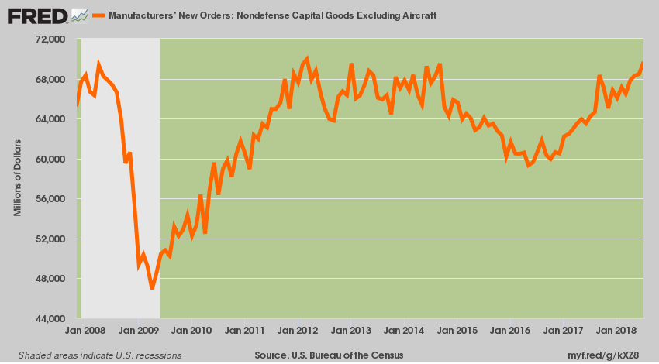
So there's no strong economy to lean on, and there is an outright collapse of governance in Imperial Washington coming rapidly down the peak.
If you were buying the Russell 2000 at yesterday's prices, take your choice. Get in line at the extreme upper right of the chart below or, in the alternative, fall-in place with the fury creatures depicted in the first chart of above.
It amounts to the same thing or like we said: Now comes the lemmings' final run.
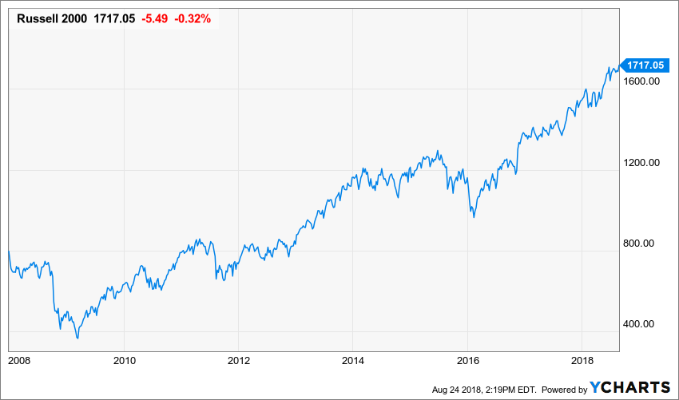
^RUT data by YCharts

